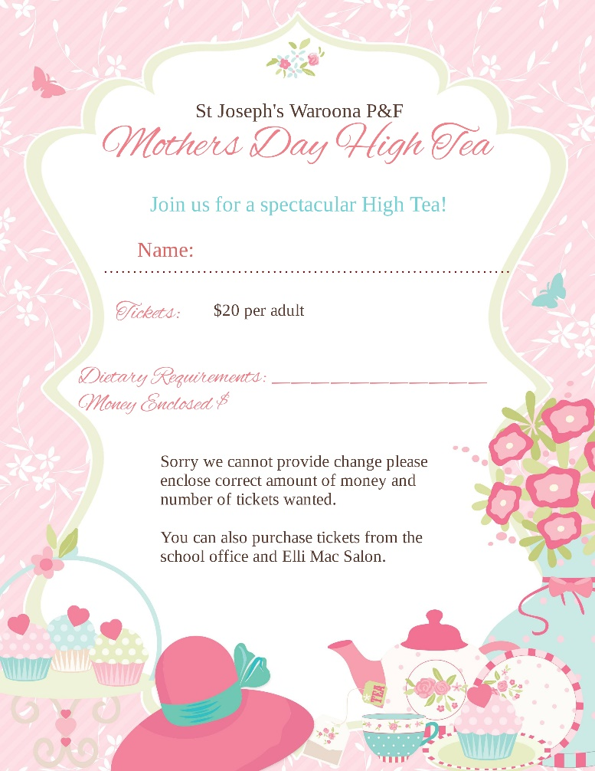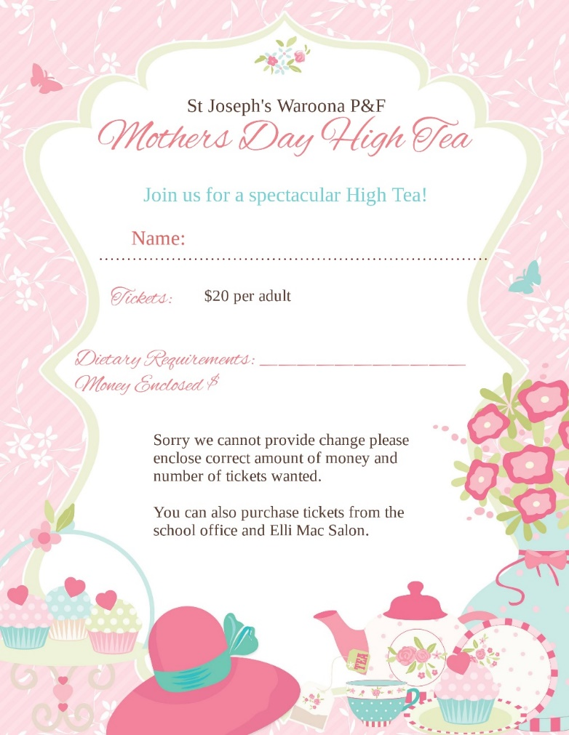
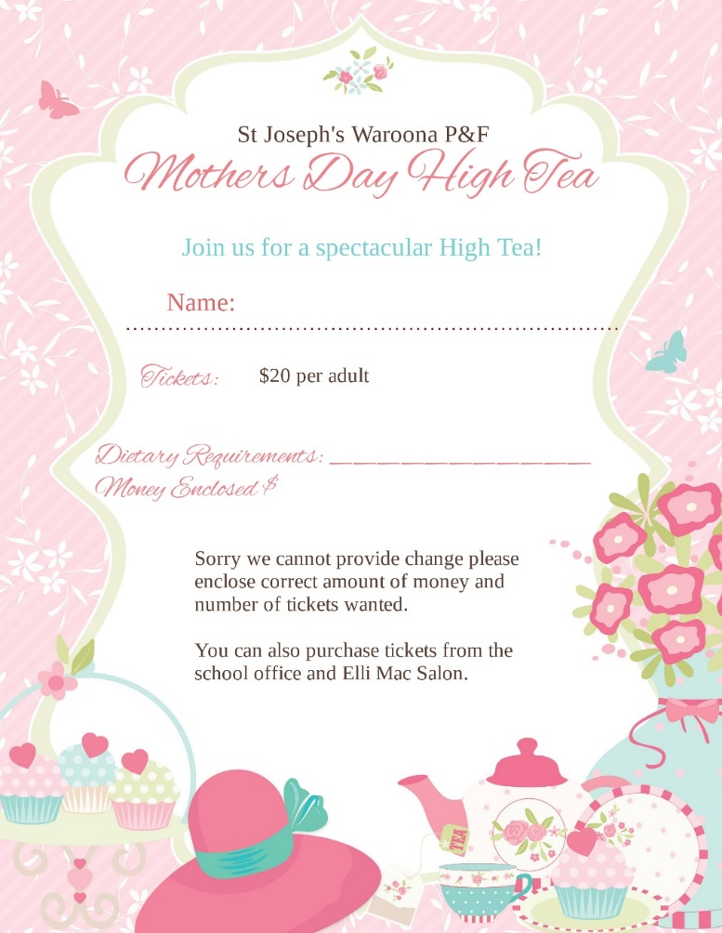

St Joseph’s School, Waroona P & F Event

Mother’s Day High Tea
We would like to invite you to our community Mother’s Day High Tea on Friday, 7th of May 2021. This event will be held in the Josephite Centre from 10am to 12noon. There will be a door prize and raffles available on the day. This event is open to school parents plus grandparents and friends too.
All money raised will go directly back into the school to help pay for shared iPads in the lower grades.
You can purchase as many tickets as you like.
Please return the attached completed form, with the correct cash, to the school office or Elli Mac Salon, Waroona.
Thank you for your ongoing support. We hope to see you there.

Kind Regards,
The P&F Association

