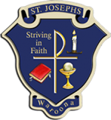

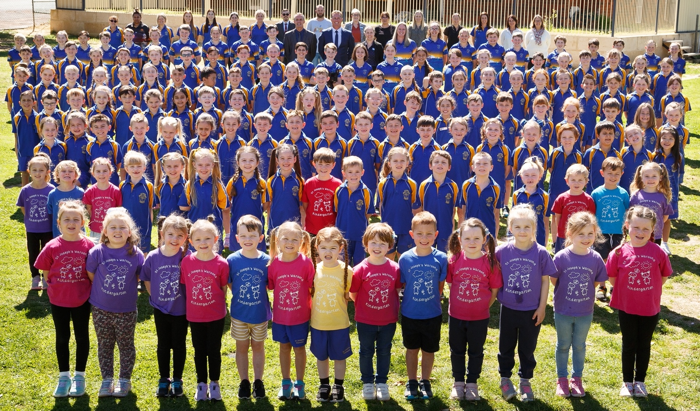

St Joseph’s School
Waroona
CATHOLIC SCHOOL IMPROVEMENT PLAN 2022
CEWA’S VISION | SCHOOL’S VISION
Catholic Education WA is a Christ-centred and child-focused community of engaged learning environments, inspiring all to actively live the Gospel. | Our mission statement is “to provide an affordable, quality Catholic education.”
Mission: St Joseph’s School, as an integral part of the Waroona Catholic Community, is inspired by Christ’s teachings. We endeavour to nurture all children to grow as confident, independent, life-long learners, enabling them to contribute to society with dignity, respect and a spirit of service.

Aspiration: 2022-25: All students to demonstrate sustained growth in Numeracy and Literacy and improved levels of collective wellbeing within our Catholic community.

Document date: 3rd February 2022

St Joseph’s School |  |  |  |  | Strategic intents should be drawn from and complementary  to CECWA’s Strategic Directions (2019-2023) with the necessary alignment and recognition to the context of the school. Strategic intents are developed through a school-wide consultative process. The strategic intents are broad goals and success factors that  can be articulated in more detail and action through the iterative School Improvement Plan. Through the cycle of strategic planning, when CECWA’s Strategic Directions are renewed, a school will factor this in when its next cycle of strategic consultation and generation of new intents over a three-year period occurs.
Waroona
STRATEGIC INTENTS | |  |  | 2022 - 2025
 |  | CATHOLIC IDENTITY Inspiring Christ-centred Leaders
 |  | Goal(s): |  | Success Indicators: |  | Links to QCE Elements:
 |  | Consolidate the use of 'Making Jesus Real' within the school to enhance a disciplined, safe and supportive working environment and incorporate into the positive behaviour school plan. |  | MJR visible across the school through interactions of staff, students and families. |  | 1.2 Advancing the Church’s mission based upon the Gospel of Jesus Christ.  2.1 Catholic World view.  3.1 Dignity of the human person.  3.1 Christ like relationships.  4.1 We exercise stewardship founded on relationships of mutual responsibility.
 |  | Engagement with our local Catholic community through involvement with St Patrick’s Parish and St Vincent de Paul Society |  | Active student participation in Parish masses, support for Altar servers and Mini Vinnies team helping Waroona’s local community. |  | 1.2 Giving witness to the Gospel through our faith, actions and relationships  1.2 Always striving to be Christ centred and child-focuses in our operations.
 |  | EDUCATION Catholic Schools of Excellence
 |  | Goal(s): |  | Success Indicators: |  | Links to QCE Elements:
 |  | Refine the whole-school approach to agreed lesson structure & High Impact Teaching in Literacy active within each classroom. |  | All students are demonstrating sustained growth in literacy.  Regular peer observations/learning. |  | 2.3 Vision for Learning:  Five quality teacher practices.  Enable learning experiences to be designed for each student to achieve their full potential. Supporting a wide range of effective instructional strategies to respond with agility to the needs of each child.
 |  | Refine the whole-school approach and agreed lesson structure & Impact Teaching in Numeracy active within each classroom. |  | All students are demonstrating sustained growth in numeracy. |  | 2.3 Vision for Learning:  Enable learning experiences to be designed for each student to achieve their full potential. Supporting a wide range of effective instructional strategies to respond with agility to the needs of each child.
 |  | Improved level of student wellbeing through improved peer connectedness and general wellbeing. |  | Student voice is evident throughout the school community and within classrooms.  Internal school survey demonstrates improvement.  2023 Climate survey demonstrates continued improvement. |  | 2.1 Catholic World view.  3.1 Dignity of the human person.  3.1 Christ like relationships.  3.1 Catholic Pastoral Communities.  Wellbeing and health – we take proactive steps to safeguard wellbeing of students
 |  | Continue to refine the process of data collection and analysis to improve the identification and tracking of student progress. |  | Student data is maintained, used to inform teaching and regularly reviewed at individual, class, and whole school level. Data regularly shared with children and parents to support engagement and achievement. |  | 1.2 Committing to excellence and continuing transformation, meeting all church and government requirements.  2.3 Encourage and facilitate student engagement.  3.2 We partner with and support parents as first educators of their children.  4.3 Decision making
 |  | Incorporate the NQS in informing improvement in the Early Years (K-2). Indoor outdoor play area, and child agency. |  | Each child’s agency is promoted, enabling them to make choices and decisions that influence events and their world. |  | 2.3 Vision for Learning:  3.1 Dignity of the human person.  3.1 Christ like relationships.
 |  | COMMUNITY Catholic Pastoral Communities
 |  | Goal(s): |  | Success Indicators: |  | Links to QCE Elements:
 |  | Transforming Lives – increase Aboriginal student enrolment to transform lives. |  | Aboriginal families as first educators programme (Afafe)  Noongar lessons in K-2 and continual learning of traditional culture  Regular meetings with local Aboriginal Elders.  Visible signs of local Aboriginal culture within our school. |  | - Our Vision  - Providing access for all parents/ children seeking a Catholic Education.  2.1 Catholic World view.  3.1 Catholic Pastoral Communities – Transforming lives, Christ like relationships.  3.3 Engagement - We engage with the wider community.  4.1 Relationships centre on care.
 |  | Increase Parent/ Caregiver involvement in student learning and achievement. |  | Regular well attended (each semester) parent information and learning sessions to support student reading, numeracy and wellbeing. |  | 1.2 Giving witness to the Gospel through our faith, actions and relationships  1.2 Always striving to be Christ centred and child-focuses in our operations.  3.2 Parents – we partner with and support parents as the first educators.
 |  | Engagement with our local Catholic community through involvement with St Patrick’s Parish and St Vincent de Paul Society, engagement with Royal Agricultural Society and Lions club. |  | Active student participation in Parish masses, support for Altar servers and Mini Vinnies team helping Waroona’s local community. Participating in local Waroona community events and with local organisations |  | 1.2 Giving witness to the Gospel through our faith, actions and relationships  1.2 Always striving to be Christ centred and child-focuses in our operations.  3.3 Engagement - We engage with the wider community
 |  | STEWARDSHIP Accessible, Affordable and Sustainable System of Schools
 |  | Goal(s): |  | Success Indicators: |  | Links to QCE Elements:
 |  | Use AISTL teacher standards to document and regularly review goals, policies and processes relating to performance for all staff. |  | Regular “Igrow” coaching (every term) for all staff, developing individual professional goals and improving professional practice. Regular Peer to peer learning. |  | - Our Vision  - Providing access for all parents/ children seeking a Catholic Education.  2.1 Catholic World view.  3.1 Catholic Pastoral Communities – Transforming lives, Christ like relationships.  3.3 Engagement - We engage with the wider community.  4.1 Relationships centre on care.
 |  | Identify potential leaders and create opportunities for distributing pedagogical leadership. |  | Active extended leadership team regularly meeting and members improving practice through, “everyone leads, framework”. Potential leaders provided with targeted training/professional development.  Student voice is actively sort out and influences all decisions within the school. |  | 2.1 Catholic World view.  3.1 Dignity of the human person.  3.1 Christ like relationships.  3.1 Catholic Pastoral Communities.  Wellbeing and health – we take proactive steps to safeguard wellbeing of students.  4.1 Relationships centred on care: We acknowledge that all of creation is a gift from God and that we are called into relationships; therefore  we care and respect all people.  4.3 Decision making. We ensure that the Catholic social teaching principals of subsidiarity, co-responsibility, common good, participation and equity are imbedded into the decision making; that all decisions are evidence based and place the child at the centre.

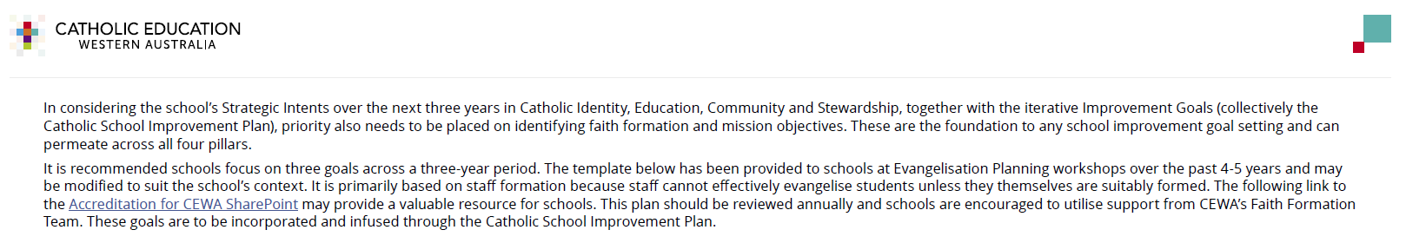
STAFF Formation Planning 2022 - 2025
Focus Area | Improvement Goals | Relevant Actions | Timeframe | Resources | Success Indicators | Monitoring and Progress
WITNESS  - Examples of expressing the divine within  - Raising awareness of the presence of Jesus |  | Annual Professional Development opportunity as a staff to further deepen their faith dimension  2022 MJR – All school leaders and new staff to be trained  2022 Eucharist  Staff Prayer |  |  | Visible signs and symbols/ MJR  Modelled by relationships (I.e. positive talk about community members)  Positive relationships and interaction between members of the school community  Positive changes to student behaviour with each other  Increased MJR nominations
CALL TO FAITH  - Themes  - Beliefs  Healing  Freedom  ‘Sight’  Strength against temptations  Consolation  Empowerment  Forgiveness  Renewal |  | - Faith formation of staff  - Masses  - Talks by Parish Priest  - Parish volunteers  - Written information and prayers  - Visuals  - Reflections/ Meditations  - Oral presentation  - Prayer posters |  |  | Visible signs and symbols/ MJR  Modelled by relationships (I.e. positive talk about community members)
CALL TO GROW IN DISCIPLESHIP  - Apostle’s Creed  - Sacraments  - Life in Christ  - Christian Prayer | Establishment and maintaining Mini Vinnies  Continuing MJR  Regular prayer | Prayer PD as part of Staff Meeting time and Prayer folder added to TEAMs with resources | PLC Prayer Term 1 2022  Catechetical Mass development with Sister Christine Clark in December 2021 (commence 2022) |  | Visible signs and symbols/ MJR  Modelled by relationships (I.e. positive talk about community members)  Positive relationships and interaction between members of the school community  Positive changes to student behaviour with each other  Increased MJR Nominations

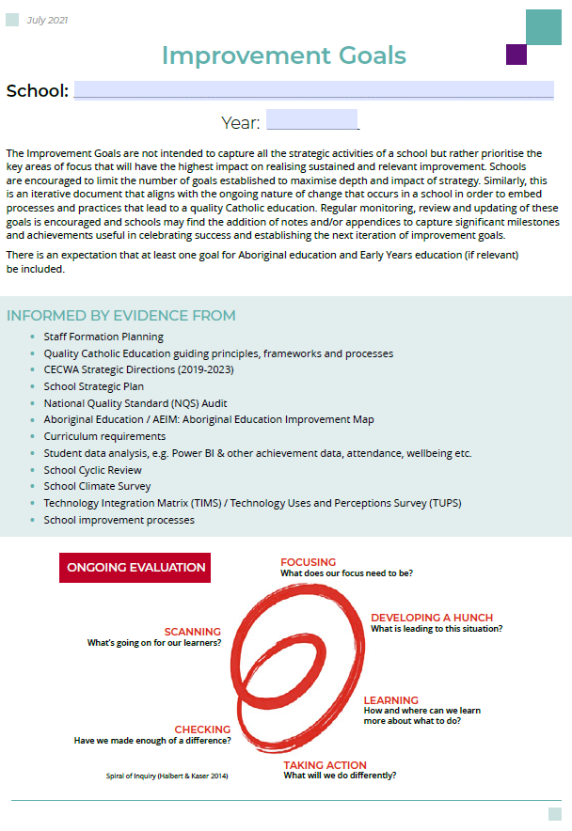
2022
St Joseph’s School - Waroona

CATHOLIC IDENTITY Inspiring Christ-centred Leaders
Improvement Goals  Performance & development goal to be achieved (stated simply). | Relevant Actions  What actions will we take to achieve the goal? | Timeframe  What are the timeframe milestones?  Timeframe within which  the goal will be achieved. | Resources  Support/resources that will be required to achieve the goal.  Key school-based personnel who will be engaged. | Success Indicators  How will we know we  have been successful  (quantitative and measurable)? | Monitoring Process and Progress  Who is the staff member who will ensure we are on track and have not taken our eyes off the goals? When/how regularly will this be done? How will this be done?
Promote/explain to the students the meaning behind the symbols, objects & icons of the Church (Years K-6). | - Provide timetable for Parish Priest on Wednesdays to visit classes  - Provide lunch for Parish Priest on Wednesday to liaise with staff  - Release staff member to provide training for Altar Servers | 1 & 2 Ongoing – commencing 2021  3 Commencing T4 2021 and ongoing | - Timetable  - Regular meetings with priest and principal  - Release time for teacher to train altar servers  - Parish Safe Guarding Officer to be appointed | - Students talk about learnings from parish priest visits confirmed via questioning of students  - Improved BRLA data in this area  - Increased number of students as altar servers | Principal – parish priests visit  Lunches – Administration officer  Altar Servers – Assistant Principal
Consolidate the use of 'Making Jesus Real' within the school to enhance a disciplined, safe and supportive working environment and incorporate into the positive behaviour school plan | - All staff trained in MJR  - MJR student leaders to provide student voice and nominations  - Whole School Rewards programme  - Every class has an active Positive Class Based Behaviour Management Programme | - Ongoing (all new staff to receive MJR training)  - MJR Student Leaders elected each semester by students  - Whole School Behaviour Management Programme commenced 2021. Reviewed 2023  - Checked quarterly through student discussion | Michael Mitchell training opportunities for staff and school developed induction/ training for student MJR leaders | Increased MJR nominations within the school  Positive classroom and playground behaviours and reduced reporting to AP and Principal | MJR Staff leader

EDUCATION Catholic Schools of Excellence
Improvement Goals  Performance & development goal to be achieved (stated simply). | Relevant Actions  What actions will we take to achieve the goal? | Timeframe  What are the timeframe milestones?  Timeframe within which  the goal will be achieved. | Resources  Support/resources that will be required to achieve the goal.  Key school-based personnel who will be engaged. | Success Indicators  How will we know we  have been successful  (quantitative and measurable)? | Monitoring Process and Progress  Who is the staff member who will ensure we are on track and have not taken our eyes off the goals? When/how regularly will this be done? How will this be done?
Refine the whole-school approach to agreed lesson structure & High Impact Teaching in Literacy. | Let’s Decode (K- 2)  Daily Reviews (3-6) | Initiate 2021 and ongoing implementation | Let’s Decode information  Daily Review templates  School Based Scope and Sequence | Class implementation of High Impact Strategies. Each student shows effective growth in excess of 0.4 | Principal and Assistant Principal  Dibels Testing  Release time for Peer Observations
Refine the whole-school approach and agreed lesson structure & Impact Teaching in Numeracy. | Whole school Numeracy block and lesson structure  Scope and Sequence across the school  Daily Reviews across all year levels | Initiate Term 4 2021 and refine in 2022 and ongoing  2022 Term3 | CEWA Numeracy Framework  School Based Scope and Sequence  Daily Review templates | Class implementation of High Impact Strategies. Each student shows effective growth in excess of 0.4  Visible class implementation of Daily Reviews | Release time for Peer Observations
Continue to refine the process of data collection and analysis to improve the identification and tracking of student progress. | Regular PLC and cluster discussions on student growth (whole school/ class/ individual) from data sources and impact of High Impact Strategies | Ongoing | Assessment Schedules  Assessment data sources | Regular Discussion of student data  Students not achieving growth targets being placed on support/ Individual Plan | Reviewed each term
Incorporate the NQS in informing improvement in the Early Years (K-2). Indoor outdoor play area, and child agency. | Element 1.2.3  Each child’s agency is promoted, enabling them to make choices and decisions that influence events and their world. | ongoing | Quality Improvement plan | Children’s work is clearly displayed inside the classrooms, on windows and walls, and digitally through Seesaw.  The educators are skilled at recognising and responding to opportunities for learning from children’s ideas, interests and play.  We use both explicit and emergent planning techniques. | Review as part of QIP.
Establishment of student voice and student leader committee to provide input into school decisions. | Establish student leadership groups – 2021 (Student Council, Mini Vinnies, Sport Leaders, Green Team)  Classrooms to introduce avenues for Student Agency in learning | Leadership groups established 2021 and then ongoing  2022 Peer to Peer observation of student agency | St Vincent dePaul Society  Release time for Peer to Peer Observations | Minutes of regular meetings kept and shared with students  Peer to Peer Observations | Meetings 2 to 3 times per term  Each term
Improved level of student wellbeing through improved peer connectedness and general wellbeing | Annual student survey measuring wellbeing | Annually | School Based Student Survey designed and administered by students | Survey results discussed by students and staff with feedback provided to parents. Suggestions to improve provided by students  Data provided through bi-annual Climate Survey | Annual school based survey  Climate survey results

COMMUNITY Catholic Pastoral Communities
Improvement Goals  Performance & development goal to be achieved (stated simply). | Relevant Actions  What actions will we take to achieve the goal? | Timeframe  What are the timeframe milestones?  Timeframe within which  the goal will be achieved. | Resources  Support/resources that will be required to achieve the goal.  Key school-based personnel who will be engaged. | Success Indicators  How will we know we  have been successful  (quantitative and measurable)? | Monitoring Process and Progress  Who is the staff member who will ensure we are on track and have not taken our eyes off the goals? When/how regularly will this be done? How will this be done?
Transforming Lives – increase Aboriginal student enrolments | Support Aboriginal families as first educators programme (Afafe)  Continue Noongar lessons in K-2  Continued Discussions with local Aboriginal Elders | Ongoing  Commenced 2021 and ongoing | CEWA Afafe Co-ordinator  Local elders and other agencies | Enrolment of at least 5% of student population | Principal
Increase Parent/ Caregiver involvement in student learning | Parent information and learning sessions to support student reading, numeracy and wellbeing  Homework policy revised and suitable readers regularly going home. | 2022 (2 parent sessions)  2023 (regular parent sessions) | Guest speakers  Hands on student/ parent engagement sessions  Support process with provision of food | Increased parent engagement in Climate Survey 2023 | Extended Leadership Team

STEWARDSHIP Accessible, Affordable and Sustainable System of Schools
Improvement Goals  Performance & development goal to be achieved (stated simply). | Relevant Actions  What actions will we take to achieve the goal? | Timeframe  What are the timeframe milestones?  Timeframe within which  the goal will be achieved. | Resources  Support/resources that will be required to achieve the goal.  Key school-based personnel who will be engaged. | Success Indicators  How will we know we  have been successful  (quantitative and measurable)? | Monitoring Process and Progress  Who is the staff member who will ensure we are on track and have not taken our eyes off the goals? When/how regularly will this be done? How will this be done?
Utilise the set of documented and regularly reviewed goals, policies and processes relating to performance for all staff. | Regular meetings and discussion in relation to goal setting with designated Coach | Ongoing with termly meeting | iGrowth Coaching Training for extended leadership team  Staff provided with suitable PD | Achievement of individual goals and development of new goals | iGrowth Coaches
Maintain peer to peer learning process. | Provide release time to teachers as required | Ongoing | Peer to Peer Observation Sheet  Assistant Principal to provide release time and relief as required | Observations and commonalities across classrooms | Peer Observer
Implement 'coaching' to further develop consistent delivery of excellent teaching practice. | Continued professional development of relevant staff as required  All staff to be receiving coaching and have an appointed coach | Initiated 2021 and ongoing  Commenced 2022 | CEWA Consultants  iCoach Formal training (CEWA’s model for whole leadership team) | All staff receive regular coaching and have a growth development plan reviewed each semester | Extended Leadership Team
Identify potential leaders and create opportunities for distributing leadership. | Discussion with identified staff and maintaining an extended leadership team | Ongoing | 2 SRA and release time | Regular meetings with Extended Leadership | Principal

Date | Progress, notes and key points

