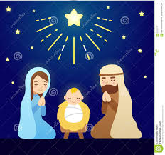

Saint Patrick’s Parish, Waroona
invites
Children and Families
to
Christmas Eve Children’s Mass
7pm – 8pm
at
St Patrick’s Catholic Church

5th December, 2019

Dear Parents and Families,

Parish Family Mass – Christmas Eve

St Patrick’s Parish and Father Con would like to invite the students of St Joseph’s to come together and celebrate a special family Mass on Christmas Eve at 7pm. During Mass, the children will receive a special blessing from Father Con and sing some Christmas carols. Wear your merriest hat and Christmas sparkles!

Please fill out the RSVP below and return it to school by Tuesday 10th December so that we can allocate readers for the Mass. If any parents, grandparents or older siblings would like to participate in the Mass they are very welcome. Please indicate below. All the readings will come from the Children’s lectionary and there will be time to practise.

We look forward to seeing you.

God Bless,

Fr Con Bagaoisan
……………………………………………………………………………………………………..

RSVP

Our family is able to attend the Christmas Eve Family Mass at 7pm.

Yes No

Family Name: _________________________ Name of Child/ren: _____________________

Please allocate _______________________________ (name of child/family member) a part in the Mass:

- Altar Serving
- Greeter (stand at the entry, say hello to people as they arrive & hand out bulletins)
- Commentator (Read the welcome everyone as Mass begins)
- 1st Reading or 2nd Reading
- Prayers of the Faithful (small part)
- Offertory (bring up the gifts)

